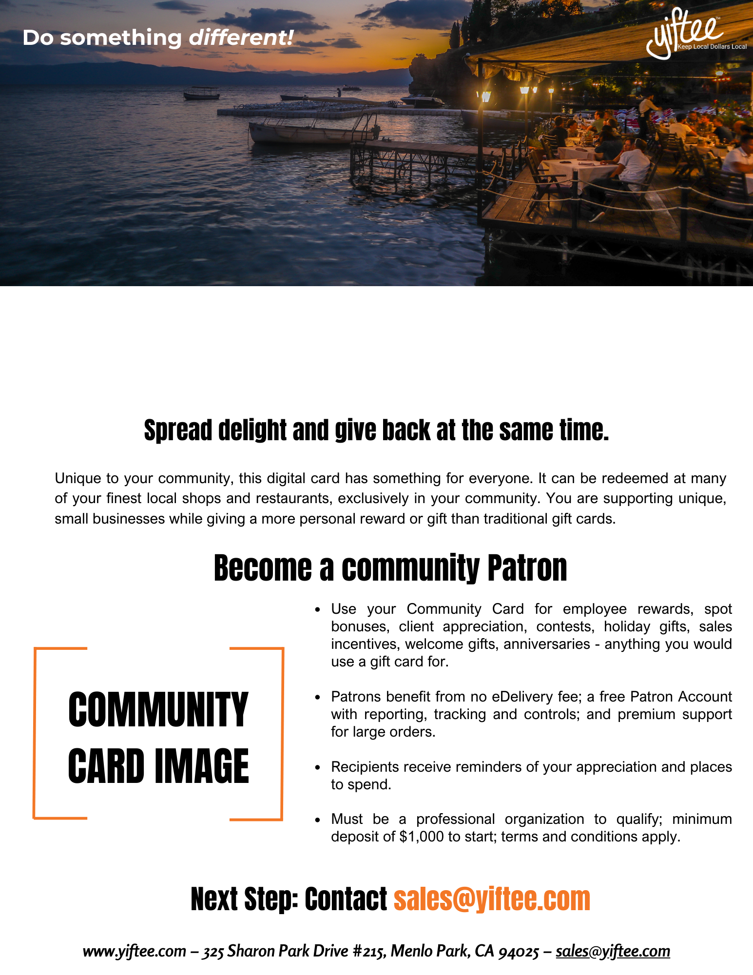

[COMMUNITY CARD NAME]: EMPLOYEE REWARDS AND CLIENT APPRECIATION WITH COMMUNITY SPIRIT!

