**CHAMBER NAME LAUNCHES CARD NAME, INVITES COMMUNITY TO CELEBRATE SMALL BUSINESS SEASON & SUPPORT LOCAL MERCHANTS**

*Now give the experience of Community Name’s unique restaurants, shops, entertainment and more*

*to friends, family, employees, and clients in one simple digital Community Gift Card.*

YOUR CITY, STATE – insert date – This year, the YOUR NAME Chamber of Commerce wants to encourage you to keep holiday shopping local. Small businesses are the backbone of our community, providing jobs, tax dollars, contributions to our schools and non-profits, as well as the character that makes our town unique. The CARD NAME is a community-based digital gift card that makes it fun and easy to keep localspending local. Purchase a CARD NAME Community Card [here](https://c.yiftee.com/gift-card/shop-cool-spring-fayetteville) to spend at one or many of NUMBER participating merchants. Recipients could use it for their latte in the morning, visit the salon next door for a pedicure, grab lunch with a friend, hit the boutiques, and meet up for date night happy hour – all using their Community Card from their mobile phone.

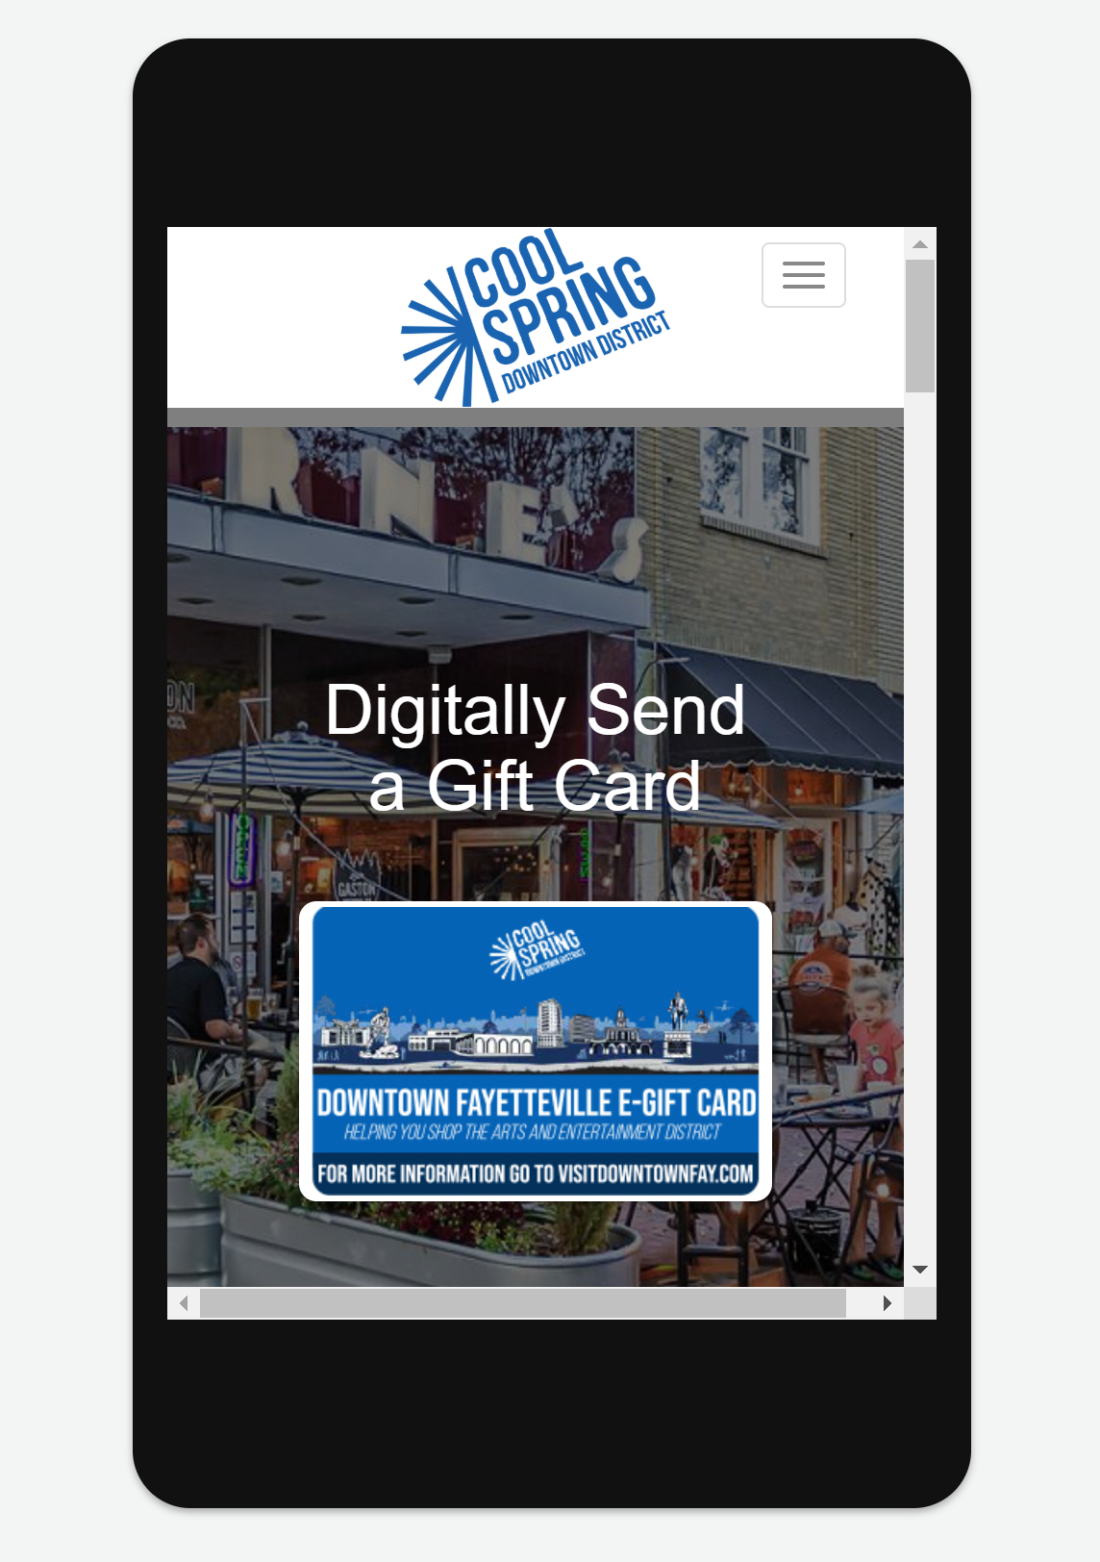

*The CARD NAME Community Card is a unique gift for employees, friends and family that supports town name. Recipients enjoy a fun experience spending it at our unique local shops, restaurants, entertainment and more.*

**Why supporting local businesses is so important**

Participating in this program means supporting the heart of what makes our community unique. The purchase of a CARD NAME Community Card creates a pool of cash that local businesses in TOWN NAME can rely on. Studies have shown that local independent retailers recirculate 47% of their revenue back into the community, while only 14% of national chains’ revenue stays in the community. More dramatically, restaurants recirculate 73% of their revenue back into the community, versus only 30% for national chains.

By supporting local businesses, more money continues circulating through the local community—this is achieved through a combination of profits paid to local business owners, wages paid to local workers, goods and services procured locally for internal use or resale, and charitable giving within the community. If you’re looking for a way to do some good or want to know how you can help the community you love, send a CARD NAME Community Card! For more information or to participate as a merchant in the program, please contact the YOUR NAME CHAMBER OF COMMERCE [here](https://visitdowntownfayetteville.com/contact-us/).

**About YOUR NAME Chamber of Commerce**

Your boilerplate goes here.

**About Yiftee, Keep Local Dollars Local**

Yiftee (Yiftee.com) serves more than 500 communities and 16,000 local businesses with simple, secure, PoS-independent Community Cards and eGift Cards that keep millions of local dollars local every year. Companies, schools, medical facilities, city governments, realtors/developers, and consumers purchase them for employees, clients, friends and family. Community Cards are FREE to set up and FREE for the merchants. Yiftee has a local partner in every community who brands and markets the program and recruits 10s to 100s of small businesses, who get incremental revenue and foot traffic. Redemption is powered by Mastercard® so no special equipment or integration is required, and implementation is quick and easy. Yiftee also provides custom-branded eGift Cards for individual merchants, franchises, and chains.