Welcome to the "My Town" eGift Card
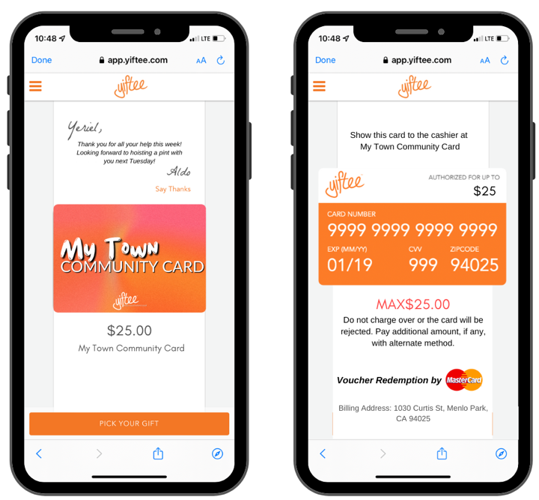
Helping Local Businesses with Pandemic Recovery and Beyond!
You’re Invited!

As a merchant in our area, we invite you to participate in our Community Gift Card program.

Why Join?
- Drive more business into your store!
- Keep customers spending local!
- Cards can ONLY be used at participating merchants!
- No special technology or administration required to participate! (Must accept Mastercard and be able to key in the transaction like a phone order.)
- No back-office administration! Funds are automatically paid to you, via your usual Mastercard processor.
- There is no fee to participate!

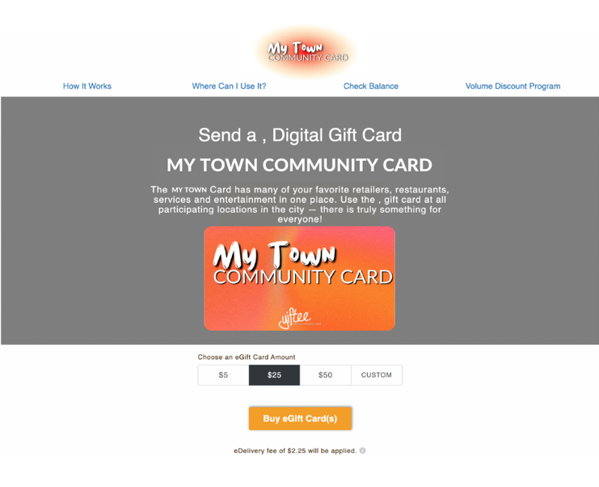
c
Community eGift Cards have kept $30M in spend local, since Jan 2020.
Who Buys Community Cards?
Customers buy them online and give them as gifts, thank yous, etc. to support local businesses. They can be purchased from our main street website, merchant websites, and Facebook pages as well!

Local companies use them for employee rewards, customer appreciation, marketing and other programs!

Realtors and other professionals use them to appreciate their customers and prospects!

Appear on Shop Concord’s custom website!

How Community eGift Cards Work (5 Simple Steps)

- SIGN UP with your local organizer – usually the City, Chamber, Main Street or Downtown Assoc.
- RUN THE “ACTIVATION CARD” as a digital Mastercard on your PoS to join.
- ADVERTISE the Community Gift Card by putting a link on your website to sell more.
- REDEEM GIFT CARDS as customers come in with a Community Gift Card on their phone (or printed).
- GET PAID as usual by your Mastercard bank. Mastercard will authorize the purchases.
Community eGift Card FAQs

Q: Is there a deadline to participate?
A: We are planning a launch on insert date to introduce the community to our new Community eGift Card. Sign up before then so that you are a part of the launch program and get this incremental business.
Q: How to I sign up?
A: Tell your community organizer that you want to participate and they will add you to the Card and send you an Activation Card, which is a 10 cent prepaid Mastercard. Running the Activation Card is your authorization to opt-in to the program which means you agree to the Yiftee Merchant Agreement here: https://yifteeutil.com/merchant-agreement
Q: What if I can’t process the Activation Card, which is a $0.10 credit card transaction?
A: No problem. Process the Activation Card for your minimum amount. It will be declined but Yiftee will get the information they need to add you to the program.
Q: What if I can’t key in a Mastercard?
A: This is very unusual. Ask your processor as this is a configuration and usually not a technical limitation. Some national chains like Walmart and McDonalds HQs do not allow their cashiers to key in the codes but the local businesses can do it.
Q: What if the purchase is for more than the Community eGift Card value?
A: Run the Community eGift Card for the remaining balance on the card, and ask the customer for a different form of payment to cover the rest of the transaction. Gift recipients can check balance on Yiftee.com or go to https://c.yiftee.com/check-gift-balance or use the link at the bottom of the printed gifts.
Q: What do I do if the eGift Card is ‘declined’?
A: The transaction is declined if you try to redeem more than the value of the card, or if any of the redemption information is mis-typed. Start the transaction over with the correct value and info. Go to https://c.yiftee.com/check-gift-balance to check the balance of a card or use the link at the bottom of printed gifts.
Q: Is tipping allowed on the Community eGift Card?
A: No, unless you pre-authorize the amount with the tip included, since this is a prepaid card.
Q: Does the eGift Card function as a ‘pre-paid’ credit card regarding automatic tipping hold-backs?
A: No. It can be redeemed for the full value. But there is no tipping allowed on the Community Card.
Q: Since the eGift Card is like a Mastercard, can it be redeemed anywhere?
A: No. They can only be redeemed at participating locations who have run their Activation Card.
Q: Is there a fee to purchase the eGift Card?
A: The gift sender pays $1.00 plus 5% of the gift value. The gift recipient gets 100% of the gift value. The store is paid the full value of the card, less their normal card-not-present (CNP) Mastercard fee.
Q: Can the eGift Card be used more than once?
A: Yes. They are multi-use and the current balance and expiration date are always reflected on the digital voucher. Recipients receive monthly reminders to redeem. You can check balance on Yiftee.com or https://c.yiftee.com/check-gift-balance or use the link at the bottom of printed gifts.
Q: Can I apply a refund to the eGift Card?
A: Yes. Refunds can be applied to a valid (unexpired) card just as you would to a credit card.
Q: Can I cancel my participation?
A: Yes. Anytime, by notifying your organizer. You will be removed from the marketing materials online and can no longer process the cards.
For more info, sign up for a demo here: https://yiftee.com/demo/

